Anthony Redamonti

Syracuse university

Project 2

CSE 681 Software modeling & analysis

prof. gregory wagner

8/16/2022

Introduction

The following project was written in C# targeting the .NET6 framework in Visual Studio 2022 IDE. The goal of the project is to send *REST get* requests to a collection of https addresses to collect JSON data. The data is converted to JSON object form and displayed to the console as team name, team code, and the record for the 2020 season. Below is a class flowchart. Please download the Newtonsoft.Json package. In Visual Studio, click Project > Manage NuGet Packages. Search for “json.” The list of packages should include “Newtonsoft.Json” by James Newton-King.

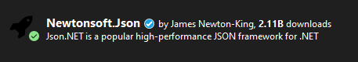

Class Flowchart:

TestFunctionality

WebClient

SeasonInfo

Utility

GameInfo

VisTeamStats

HomeTeamStats

System Flowchart:

Response: JSON data (string)

Project2.exe https://sports.snoozle.net/...teamName=1 Internet Response  
 Request JSON data (string)

API for online web server connected to a database.

System Behavior:

1. The Project2.exe sends a series of REST get requests targeting the API of an online server using a specific https address.
2. The WebClient class in the Windows .NET framework uses the https address to find the API and forwards the request to it using the Internet.
3. The API sends a response back in the form of a serialized JSON string using the IP address of the requesting application.
4. The executable deserializes the data using the JsonConvert class’s DeserializeObject method in the form of a SeasonInfo JSON object. The contents of the object are used to calculate the team name, code, and record, all of which are displayed to the console.

TestFunctionality Class

The TestFunctionality class composes instances of the WebClient, Utility, and SeasonInfo classes. It uses the Utility class’s loadUrlList method to alter the URL provided so that there are 32 unique URLs in the URL list passed to the method. Each of the URLs are passed to the WebClient class’s DownloadString method to convert their contents to a JSON string. The JSON string and an instance of the SeasonInfo class are passed to the Utility class’s createSeasonInfoObj method, which deserializes the JSON string into a JSON object. The content of the SeasonInfo object is then displayed using its displayContent method.

Utility Class

The createSeasonInfoObj method deserializes the JSON string into a JSON object in the form of a SeasonInfo object. The loadUrlList method alters the URL so that each team has a unique URL in the list.

Season Info Class

The SeasonInfo class has a JsonProperty “matchUpStats” which contains a list of GameInfo objects. It also has a public method to display the content to the console. It also holds important information for the team associated with the season: team code, team name, and record (wins, losses, and ties). There is a method to calculate the team code, team name, and the record.

GameInfo Class

The GameInfo class has the following JSON properties: visTeamName, visStats, homeTeamName, and homeStats. It also has as a public method to display the content to the console and contains instances of the HomeTeamStats and VisTeamStats classes. It also has a method “didTeamWin” which takes in a team code as an argument and determines whether the team matching that code won or lost the game. DidTeamWin has 3 private helper methods: matchTeamCode, findWinner, and winOrLoss. MatchTeamCode matches the team code with the home or visiting team code. FindWinner determines if the home or visiting team won the game. WinOrLoss calculates if the team with the entered team code won or lost the game.

HomeTeamStats and VisTeamStats Classes

Both classes have the following JSON properties: team code and score. Both are strings. They also have a public method to display the content to the console.

Example Output:

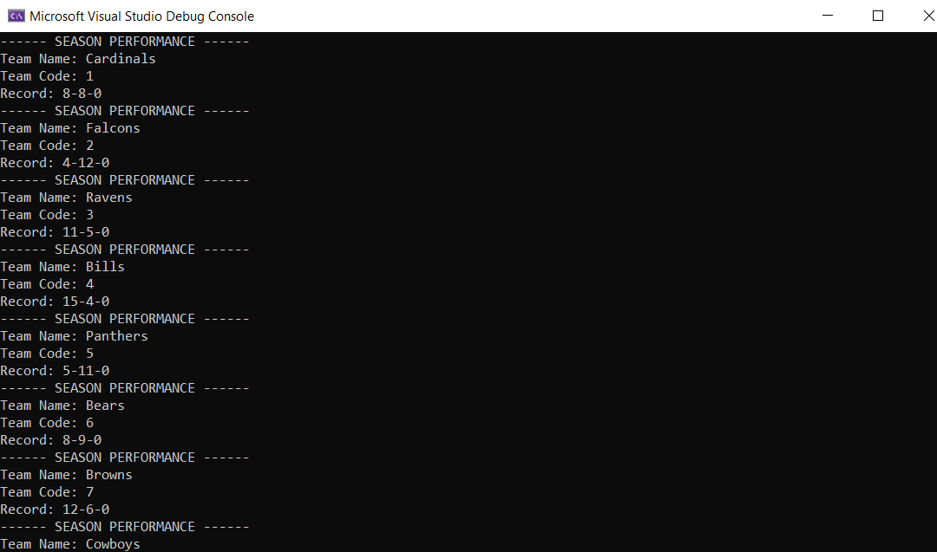  
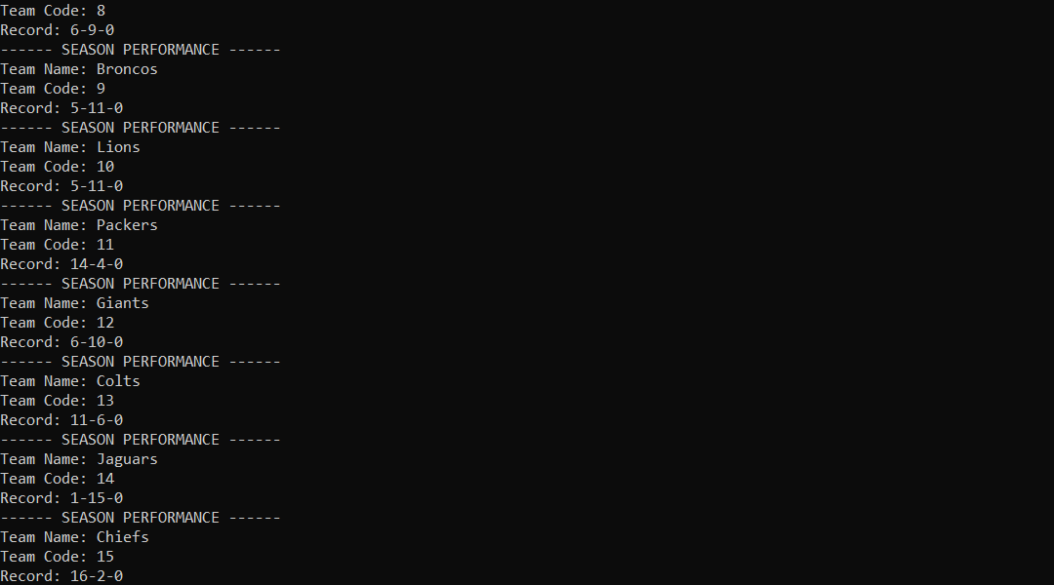  
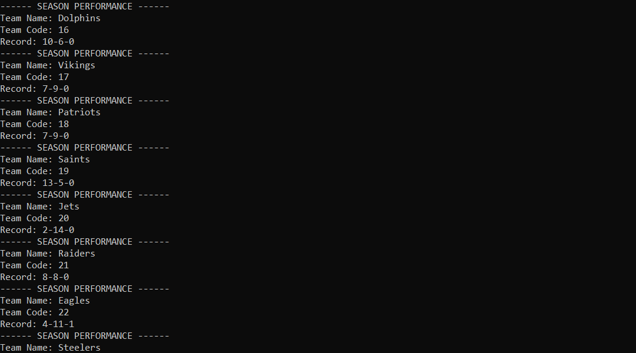  
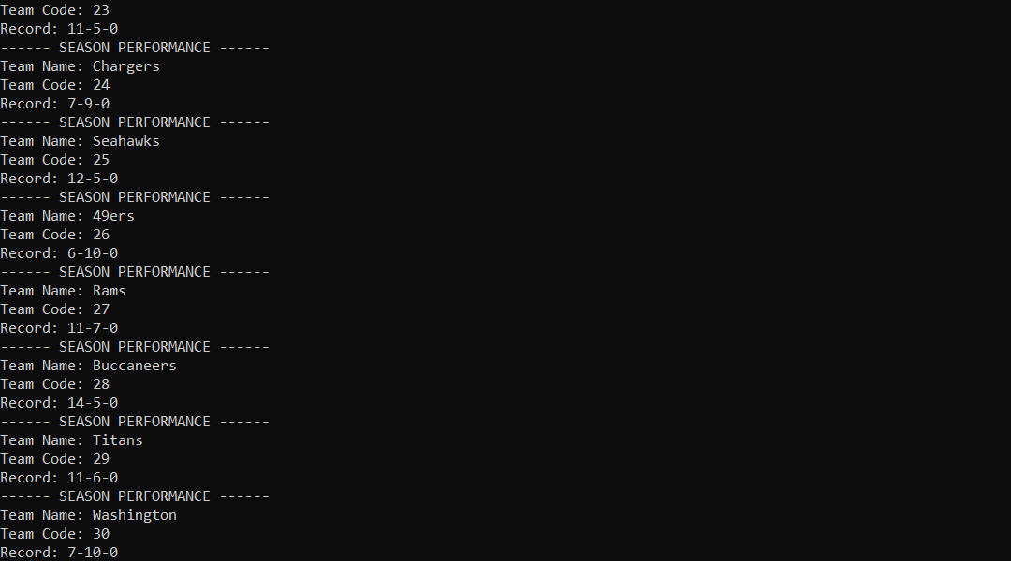  
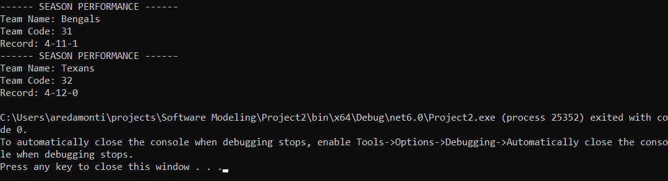

Project2.cs File

The CS file is attached to the project submission.

Extra Credit:

Extra Credit: The team codes are numbered based on the alphabetical order of each team’s city’s location.

Example:

1: Arizona Cardinals

2: Atlanta Falcons

3: Baltimore Ravens

Etc.